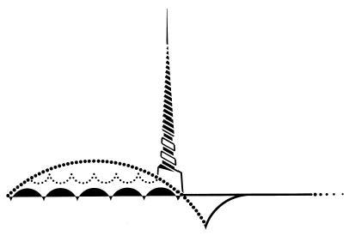

Mental Health Practitioner/Licensed MHP Bilingual
Outreach & Engagement Program
Health & Human Services
$6,963-$8,395 / Month
Marin County
San Rafael, CA

The Marin County Human Resources Department and the Marin County Department of Health and Human Services are accepting applications for the position of Mental Health Practitioner/Licensed MHP Bilingual. There is one full-time vacancy available.

Under the direction of the BHRS Unit Supervisor, the Mental Health Practitioner (MHP) in the Outreach and Engagement program provides intensive case management services to adults and/or older adults with serious mental illness who may have substance use disorders and/or complex medical conditions. These consumers typically do not want or do not think they need treatment and care. The Practitioner in this position works to build a trusting alliance and influence toward accepting help and treatment. In addition, the Mental Health Practitioner provides on-going comprehensive clinical assessment and treatment planning and acts as client advocate when clients are unable to advocate for themselves. The MHP works collaboratively with fellow clinicians in the Mobile Crisis Continuum and has the ability to partner with peer providers as well as family partners in a mutually productive way. The MHP is responsible for clear, organized documentation and works with other community providers in a coordinated manner to provide services depending on the need.

To apply or learn more about this position, visit our website: Mental Health Practitioner/Licensed MHP Bilingual Posting

Filing Deadline: Open Until Filled. Resumes are not accepted in lieu of County application and supplemental application form. Apply online at: www.marincounty.org/Jobs or contact Marin County HR Dept, Rm 126, 3501 Civic Center Dr., San Rafael, CA 94903 or call (415) 473-6104. EEO/TTY

